COOROY AREA RESIDENTS ASSOCIATION Inc.

AGM Minutes 2024

**2024 Annual General Meeting at Cooroy Library**

**Tuesday 28 January 2025** (postponed from December 2024)

President Rod Ritchie declared the meeting open at 5.15 pm.

**WELCOME TO COUNTRY**

Rod Ritchie also extended a warm welcome to Cr Tom Wegener and Deputy Mayor Brian Stockwell, and CARA members and guests.

**ATTENDANCE AND APOLOGIES**

**Apologies**

Pat Spicer and Marie Sulda

**Attendance**

Committee members: Rod Ritchie, Julia Walkden, Jennifer Sadler, Duncan Macqueen, Alan Hodgkinson.

Ordinary Members: Crs Brian Stockwell and Tom Wegener, Pam Macqueen, Carol Watkins, Cliff Dawson, Hew Werrett, Ray Kelly, Cheryl Davies and Ashley Spresser.

Guests attending: Margie Wegener and John Hartley.

**CONFIRMATION OF THE MINUTES OF THE 2023 AGM**

Resolved that the Minutes of 2023 AGM are confirmed.

Moved: Duncan Macqueen Seconded: Rod Ritchie **Carried unanimously**

**RECEIVE PRESIDENT’S REPORT**

Find the report here:[www.cooroy.org](http://www.cooroy.org)

Resolved that the President’s Report as given by Rod Ritchie be accepted.

Moved: Julia Walkden Seconded: Jennifer Sadler **Carried unanimously**

**RECEIVE and ACCEPT TREASURER’S REPORT**

Resolved that the Financial Statements and signed Statement for the year ended 30 June 2023, as presented by Jennifer Sadler, are accepted. (See report below.)

Moved: Duncan Macqueen Seconded: Cheryl Davies **Carried unanimously**

**ELECTION OF OFFICE BEARERS AND MANAGEMENT COMMITTEE FOR 2025**

The management committee and office bearers resigned and Cr Brian Stockwell took the Chair and called for nomination. Jennifer Sadler nominated Julia Walkden for secretary, seconded by Duncan Macqueen; Julia Walkden nominated Jennifer Sadler for treasurer, seconded by Rod Ritchie; Jennifer Sadler nominated Rod Ritchie for president, seconded by Duncan Macqueen; Julia Walkden nominated Duncan Macqueen for committee member, seconded by Rod Ritchie; Jennifer Sadler nominated Alan Hodgkinson for committee member, seconded by Duncan Macqueen. There were no other nominations.

**Carried unanimously**

President: Rod Ritchie, Secretary: Julia Walkden, Treasurer: Jennifer Sadler.

Committee members: Duncan McQueen and Alan Hodgkinson.

Rod Ritchie resumed the Chair.

**Councillor Stockwell** gave a well-received talk on Noosa’s ‘population cap’ and its changes over the years and possibilities into the future.

**A question and answer session** followed on other council matters.

There being no further business, the President declared the meeting closed at 6.30 pm. The date and location for the next AGM will be announced.

President - Rod Ritchie

Secretary - Julia Walkden

Treasurer – Jennifer Sadler

**Treasurer’s Report**

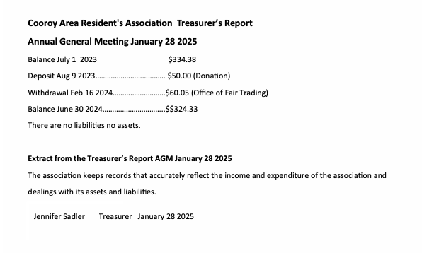

423 Old Ceylon Rd, Cooroy QLD 4563 - [caracooroy@yahoo.com](mailto:caracooroy@yahoo.com) - [www.cooroy.org](http://www.cooroy.org)